**The Core Transaction: How Platforms Facilitate Exchange**

The core transaction is the set of actions users must complete in order to exchange value on the platform, the cornerstone for any platform business.

No matter which way slice it, each and every platform has a core transaction. On Uber, drivers toggle their availability to drive and consumers submit requests for rides. On YouTube, producers upload videos and consumers find, watch, rate and share them. On Android, consumers download and use apps while developers create and publish them.

These simple examples highlight the core transaction’s main purpose: to construct a set of simple, repeatable actions that producers and consumers can take in order to create and consume value.

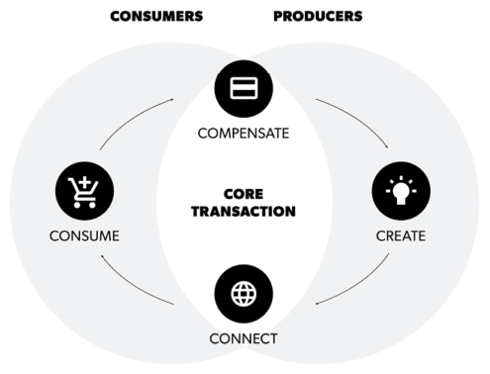

This is the key process to understand in platform design, as the core transaction will dictate your platform’s type and how you need to address the four functions. It’s also one of the earliest decisions to make in platform design.

At a high level, the core transaction in every platform contains the same basic set of four actions. These are:

1. Create: A producer creates value and makes it available via the platform
2. Connect: One user takes an action that connects them to that value
3. Consumer: A user consumes the value created by the producer.
4. Compensate: Consumers return value to the producer in exchange for what they consumed.

<https://www.applicoinc.com/blog/core-transaction-platforms-facilitate-exchange/>

1. **Discovery and Initial Contact:**
   * The customer, let's say a small business owner, discovers CinqueDev Solutions through a web search or a referral.
   * They visit the company website to learn more about the services offered and the company's approach to technology solutions.
2. **Initial Inquiry:**
   * Impressed by CinqueDev's mission and offerings, the business owner decides to reach out for more information.
   * They fill out a contact form on the website or call the provided phone number to initiate contact.
3. **Consultation and Needs Assessment:**
   * A representative from CinqueDev promptly responds to the inquiry and schedules a consultation meeting with the business owner.
   * During the consultation, the CinqueDev representative listens to the business owner's challenges, goals, and requirements.
4. **Solution Proposal:**
   * Based on the information gathered during the consultation, CinqueDev prepares a tailored proposal outlining recommended solutions to address the business owner's specific needs.
   * The proposal includes details such as the scope of work, project timeline, pricing options, and potential outcomes.
5. **Proposal Review and Agreement:**
   * The business owner reviews the proposal and discusses any questions or concerns with the CinqueDev representative.
   * After clarifications and potential negotiations, the business owner agrees to the proposed solution and signs a service agreement with CinqueDev.
6. **Project Kickoff:**
   * With the agreement in place, CinqueDev initiates the project kickoff, assigning a dedicated project manager and assembling a team of skilled professionals.
7. **Solution Development and Implementation:**
   * CinqueDev works diligently on developing and implementing the agreed-upon solutions, keeping the business owner updated on progress and milestones.
8. **Testing and Quality Assurance:**
   * Prior to deployment, CinqueDev conducts thorough testing and quality assurance checks to ensure the solutions meet the required standards and are free from defects.
9. **Deployment and Integration:**
   * Once the solutions are ready, CinqueDev deploys them to the business owner's environment, ensuring seamless integration with existing systems and processes.
10. **Training and Support:**
    * CinqueDev provides comprehensive training sessions for the business owner and their staff to ensure they can effectively utilize the implemented solutions.
    * Ongoing support and maintenance services are also offered to address any issues or concerns that may arise post-deployment.
11. **Feedback and Evaluation:**
    * Following implementation, CinqueDev seeks feedback from the business owner regarding their experience with the services provided.
    * Both parties may conduct an evaluation to assess the success of the engagement and identify areas for improvement.

Itong 1-11 na to generated to na core transaction tas ito ung mga naisip ko sa dyan

1

-meron na tayo website kaya okay na ato

2

-meron narin tayong contact form sa website

-bale sa system meron tayo kunwari database na ang laman ay puro inquiry

-paranag table lang siguro ng ang fields ung laman ng form

3

-dito pwede tayo mag assign kunwari ng tao sa company para mismong kumausap dito

-scheduling system? basic lang parang mag aasign lang tayo ng tao natin tas ung nag inquire tas kailan anong date

4-5

-dito parang kadugtong siguro ng 2-3 pero may status para indicator na may process

-dito parang idedeclare narin kung anong price nung system

-dito din ung parang may contract na siguro tas lahat ng mga papers tungkol sa agreement kunwari meron tas pwede makita

dito narin tayo mag lalagay ng transaction history at parang POS?

6,7,8,9

-wala ko maisip dito pero related kasi eh development phase nato eh wala naman na kailangan dito kasi work on background parang ganun

-pero siguro mag lalagay nalang tayo panibagong table connected sa 2,3,4,5 tas may naka assign na na team tas may status ulet para kunwari may process na

10-11

-panibagong scheduling

-tas meron survey form tas ung feedback makikita sa system

In the context of managing inquiries for software solution services, possible statuses could include:

1. **New**: The inquiry has been received but not yet reviewed.
2. **In Progress**: The inquiry is currently being reviewed or handled by a team member.
3. **Pending Response**: Additional information or clarification is needed from the customer, and the team is waiting for a response.
4. **Follow-Up Required**: The team needs to follow up with the customer for further discussion or information.
5. **Quoted**: A quote or proposal has been sent to the customer.
6. **Accepted**: The customer has accepted the quote or proposal.
7. **Rejected**: The customer has rejected the quote or proposal.
8. **Completed**: The inquiry has been successfully resolved and any requested service has been completed.
9. **Cancelled**: The inquiry has been cancelled by the customer or the team.
10. **Closed**: The inquiry is closed for other reasons, such as inactivity or inability to fulfill the request.

These statuses help in tracking and managing the progress of customer inquiries efficiently.